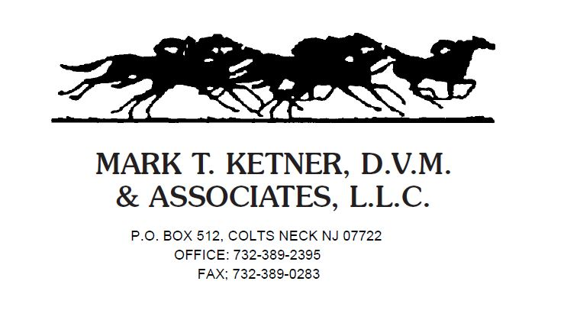

Name: _____________________________________________________

Address: ___________________________Town/ City: _______________

State: _____ Zip Code: ____________

Phone Number: Cell: ____________________Home: _________________

E-mail Address: _______________________________________________

HORSE(S) NAME(S): ___________________________________________

STABLE/FARM: ________________________________________________

ADDRESS: ____________________________________________________

Card type: Visa MasterCard Discover Amex

Credit Card #: __________________________________________________

Expiration: ___________ Security Code: ___________

_____PAYMENT BY CREDIT CARD
I hereby authorize Mark T. Ketner DVM and Associates LLC to keep a credit card on file and to process any account balance on my card 10 business days after services are rendered to my horse(s).

OR

_____PAYMENT BY CASH OR CHECK
I would like to pay by cash or check and understand that to do so I must keep a valid credit card on file. I also understand that, if payment for services is not received within 10 business days of service, the balance of my account will be charged to the credit card on file.

Signature ___________________________________ Date_____________

